2017 Community Benefits Report

A Community Health Needs Assessment Report
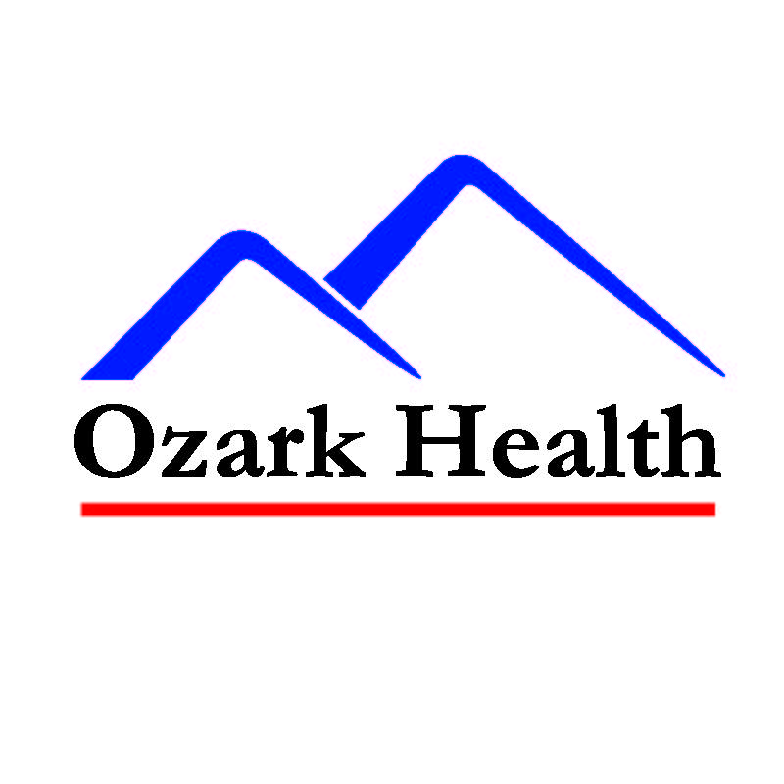

Table of Contents

Mission of Service 1
Improving Quality of Life 2-3
Financial Contributions 4
Our Partners 5
Ozark Health Foundation 6
Current Programs/Services 7-13
Young Moms Healthy Families 7
Reach Out and Connect 8
Medication Assistance Program 9
Diabetes Self-Management 10
Van Buren County TEA Coalition 11
Searcy & Van Buren County Tobacco Prevention 12
Searcy County Prevention Coalition 13
Geographic Area of Coverage 14
Community Demographics 15
2011 Financial Report 16
Searcy & Van Buren County 2009 Health Survey 17-18
Searcy & Van Buren County Health Issues 19
Community Goals & Objectives 20
Accomplishments from 2013-2016………………………………………………21-23
Obesity 24
Substance Abuse 25
Making the Most of our Efforts 26
Looking to the Future 27
Ozark Health Services 28-37
Special Thanks 38

Our Mission of Service

At Ozark Health, our mission is to provide the absolut
e best level of quality care to our patients and our residents. This is reflected in our Mission Statement: “Always Provide Outstanding Health Care!”

While the meaning of this statement can be taken in different ways, our highly qualified medical staff and volunteers take great strides in providing top level care for all who enter our doors; someone receiving critical emergency care, a patient recovering from surgery, or a family member concerned about a resident in the Nursing Center. Everyone deserves our ABSOLUTE BEST, and that’s exactly what they will get at Ozark Health.

We value our community and the people that we serve. The main population served by Ozark Health Medical Center and our ancillary programs includes Van Buren and Searcy Counties in rural North Central Arkansas.

Improving the Quality of Life for the People We Serve

As a community hospital, we do more than just provide healthcare to people when they are sick, we work each and every day to improve the health of the families that we serve through community events, education, and screenings. Our goal is not just to help people when they are sick, but to help prevent them from becoming sick and improve the quality of life for all residents of Van Buren and Searcy Counties. All of these efforts are combined in our Community Benefit. We provide an annual report of our Community Benefit, in compliance with the IRS Schedule H (Form 990).

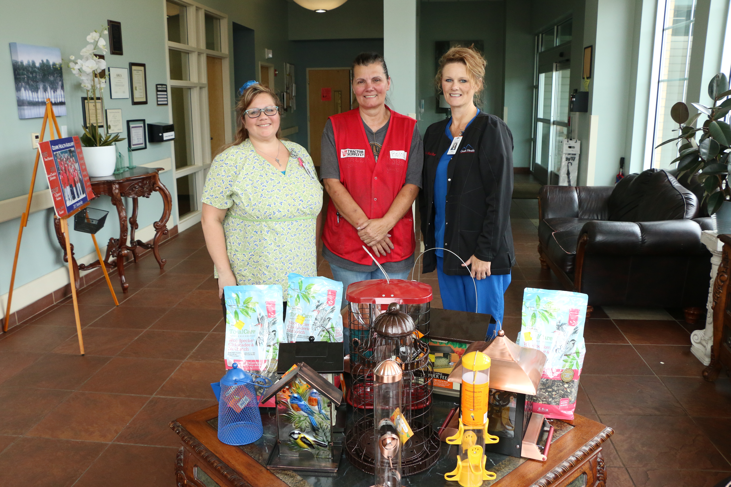
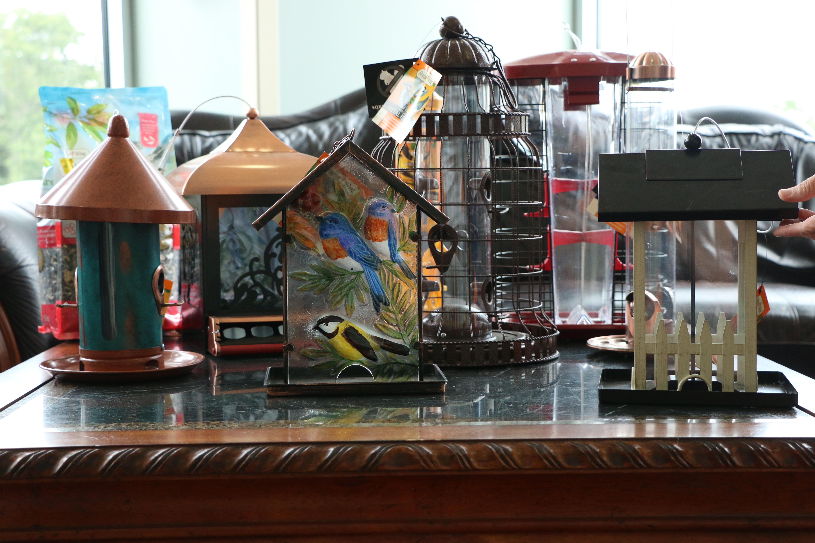

Financial Contribution to our Community

On average, we have approximately 40 employees at any given time, representing roughly $12 Million in wages paid annually. Ozark Health is the largest employer in the two-county area, followed by the public school system.
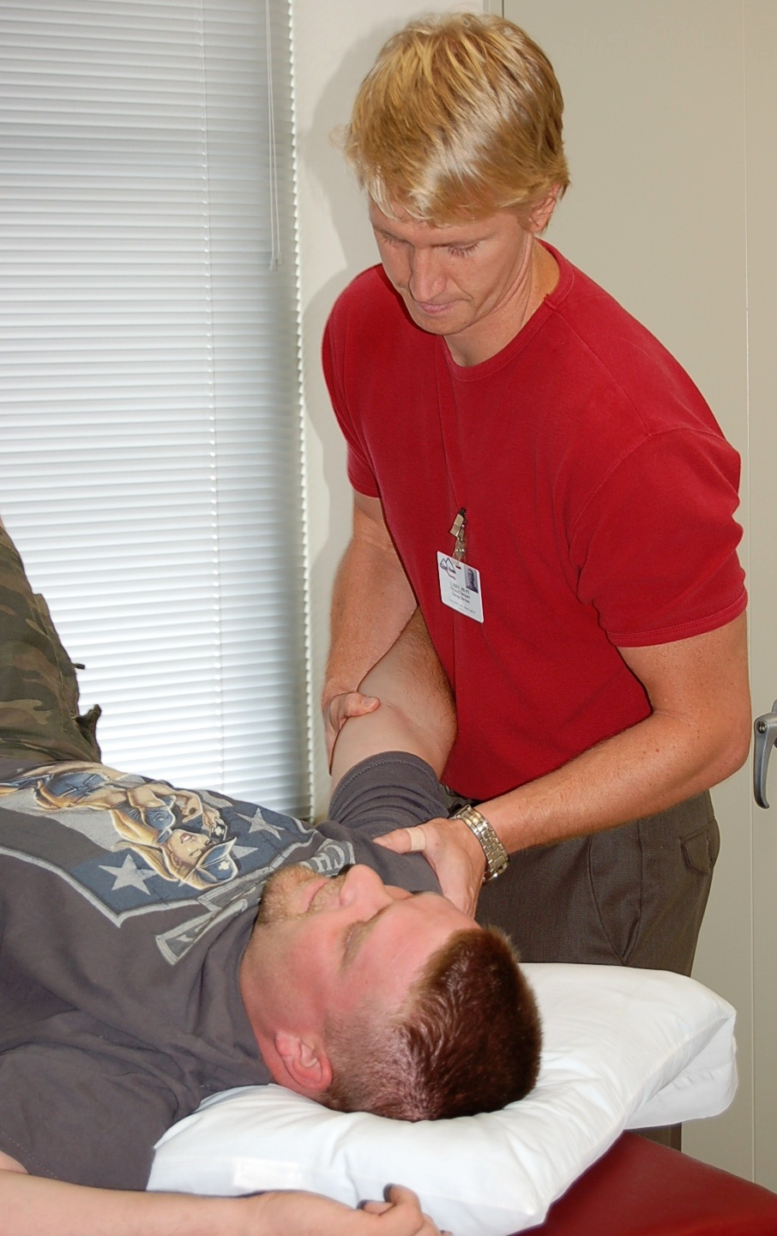

To keep the community informed and to constantly assess the pulse of the people we serve, we have a presence in the Clinton, Fairfield Bay, and Marshall Rotary Clubs and the Clinton and Marshall Area Chamber of Commerce.

To date, there have been about $1.45 Million in Donations to the Ozark Health Foundation. Additionally, about $725,000 has been awarded to current and future Ozark Health employees in Scholarships and medical equipment purchases for the facility. The total charity write off for fiscal year end 2017 was $688,024.

The amount of grant funding that has been received for Community Health Programs is just over $6 Million, all of which has been used to improve the quality of life for Van Buren and Searcy County residents over the past nine years.

Our Partners within the Community

Arkansas Department of Health-Van Buren County and Searcy County Health Units, as well as the numerous services and technical assistance provided by their state-wide programs.

University of Arkansas for Medical Sciences (UAMS) has provided assistance through both their Rural Hospital Improvement Program and the North Central Area Health Education Center. In addition, our partnership with UAMS’s AR Saves Stroke Program allows us to connect with UAMS via high-speed video communication in order quickly and effectively treat patients who come into our facility with stroke symptoms.

Local Physicians provide referrals and cooperate with each of our programs, creating a system of care that encompasses all areas of patient health.

The Ozark Health Specialty Clinic brings a variety of physicians who specialize in specific areas of the medical field to the Clinton area on specific clinic days each month. This clinic offers the residents of this rural area access to medical services that would usually only be available in larger communities.

In 2011, Central Arkansas Radiation Therapy Institute (CARTI) and Little Rock Hematology and Oncology joined forces to streamline their cancer treatment services in Central Arkansas. Prior to that time Little Rock Hematology and Oncology had provided chemotherapy and oncology services to the residents of our community through bi-monthly clinics, now since partnering with CARTI, they are able to provide these services at our facility on a weekly basis.

Ozark Mountain Health Network is comprised of different health and human service agencies, creating an integrated network of rural providers delivering quality, low-cost primary, preventive, and specialty care within our local community, and supported, when appropriate, by mutually advantageous links with outside providers.

Friendship Community Care is a new partner organization that brings knowledge and expertise of developmental disabilities in children. They are a day care and preschool that has teachers, therapists, and waiver services for their clients.

The Ozark Health Auxiliary is a group of volunteers who assist the hospital with a variety of services and donations which include the Ozark Health Gift Shop, employee scholarships, and providing assistance on chemotherapy clinic days.

The Van Buren County TEA Coalition is Van Buren County’s substance abuse prevention coalition and works alongside Ozark Health to provide substance use prevention programs throughout the community year round.

The Searcy County Prevention Coalition promotes a drug-free community by educating and motivating families and community citizens toward healthy behaviors.

Boston Mountain is a group of rural health centers committed to providing health care services to patients in Searcy, Van Buren, Madison, Newton, Marion, and Carroll County, Arkansas, regardless of their ability to pay.

Ozark Health Foundation
The primary focus of the Ozark Health Foundation is to secure funds for the purchase of medical equipment for Ozark Health and to provide an opportunity for area students and Ozark Health Employees to receive scholarships to continue their education. The Ozark Health Foundation also services as the Fiscal Agent for grants
through the Ozark Mountain Health Network.

Foundation Coordinator: Tawny Basinger, since October 2007
Amount of Funding July 2016 – June 2017: $150,000
Amount of Funding to Date: $1,600,000
Biggest Foundation Accomplishments July 2016 – June 2017
1. $28,867 was awarded to current and future for Ozark Health Employee for traditional and Continuing Education and Certification Scholarships.
2. $32,071 in Equipment was provided to Ozark Health Medical Center and Nursing &
Rehab Center.
3. $42,510 in Net Revenue from 2 Major Events

Biggest Foundation Goals (July 2017 – June 2018)
1. Implement a Planned Giving Program for donors that creates awareness about
the opportunity to include the Ozark Health Foundation in their will or trust
2. Increase the number and value of donations that are received through direct acts
from Major Donors
3. Begin a Grateful Patient Program through the Emergency, Surgery, and Inpatient
care Departments that allows people to recognize the outstanding care they received
from a member of our staff by making a donation to the Foundation.

Plan for Sustainability:
The Ozark Health Foundation is sustained through investments from private donors. To date
The majority of the Foundation Staff’s time has been spent on Fundraising Events. Over the past few years, Annual Giving has been another revenue stream that has allowed directly for the purchase of medical equipment. Planned Giving, such as Estate Planning, could provide a more sustainable and
long term income for the Foundation.

Message from Tawny:
The Ozark Health Foundation is continuously growing and changing. We began in 2003 as an
employee run organization that was interested in raising more to provide scholarships and equipment for Ozark Health. We have grown to include a 13-member Volunteer Board whose sole purpose is to raise funds and determine projects that will benefit from those funds. Because of
our partnership with Ozark Health, the Ozark Health Foundation has no administrative costs so 100%
of the money used can go to scholarships and medical equipment.

To date, there have been about $1.6 Million in Donations to the Ozark Health Foundation.
Additionally, about $785​,000 has been awarded to current and future Ozark Health employees in Scholarships and medical equipment purchases for the facility.

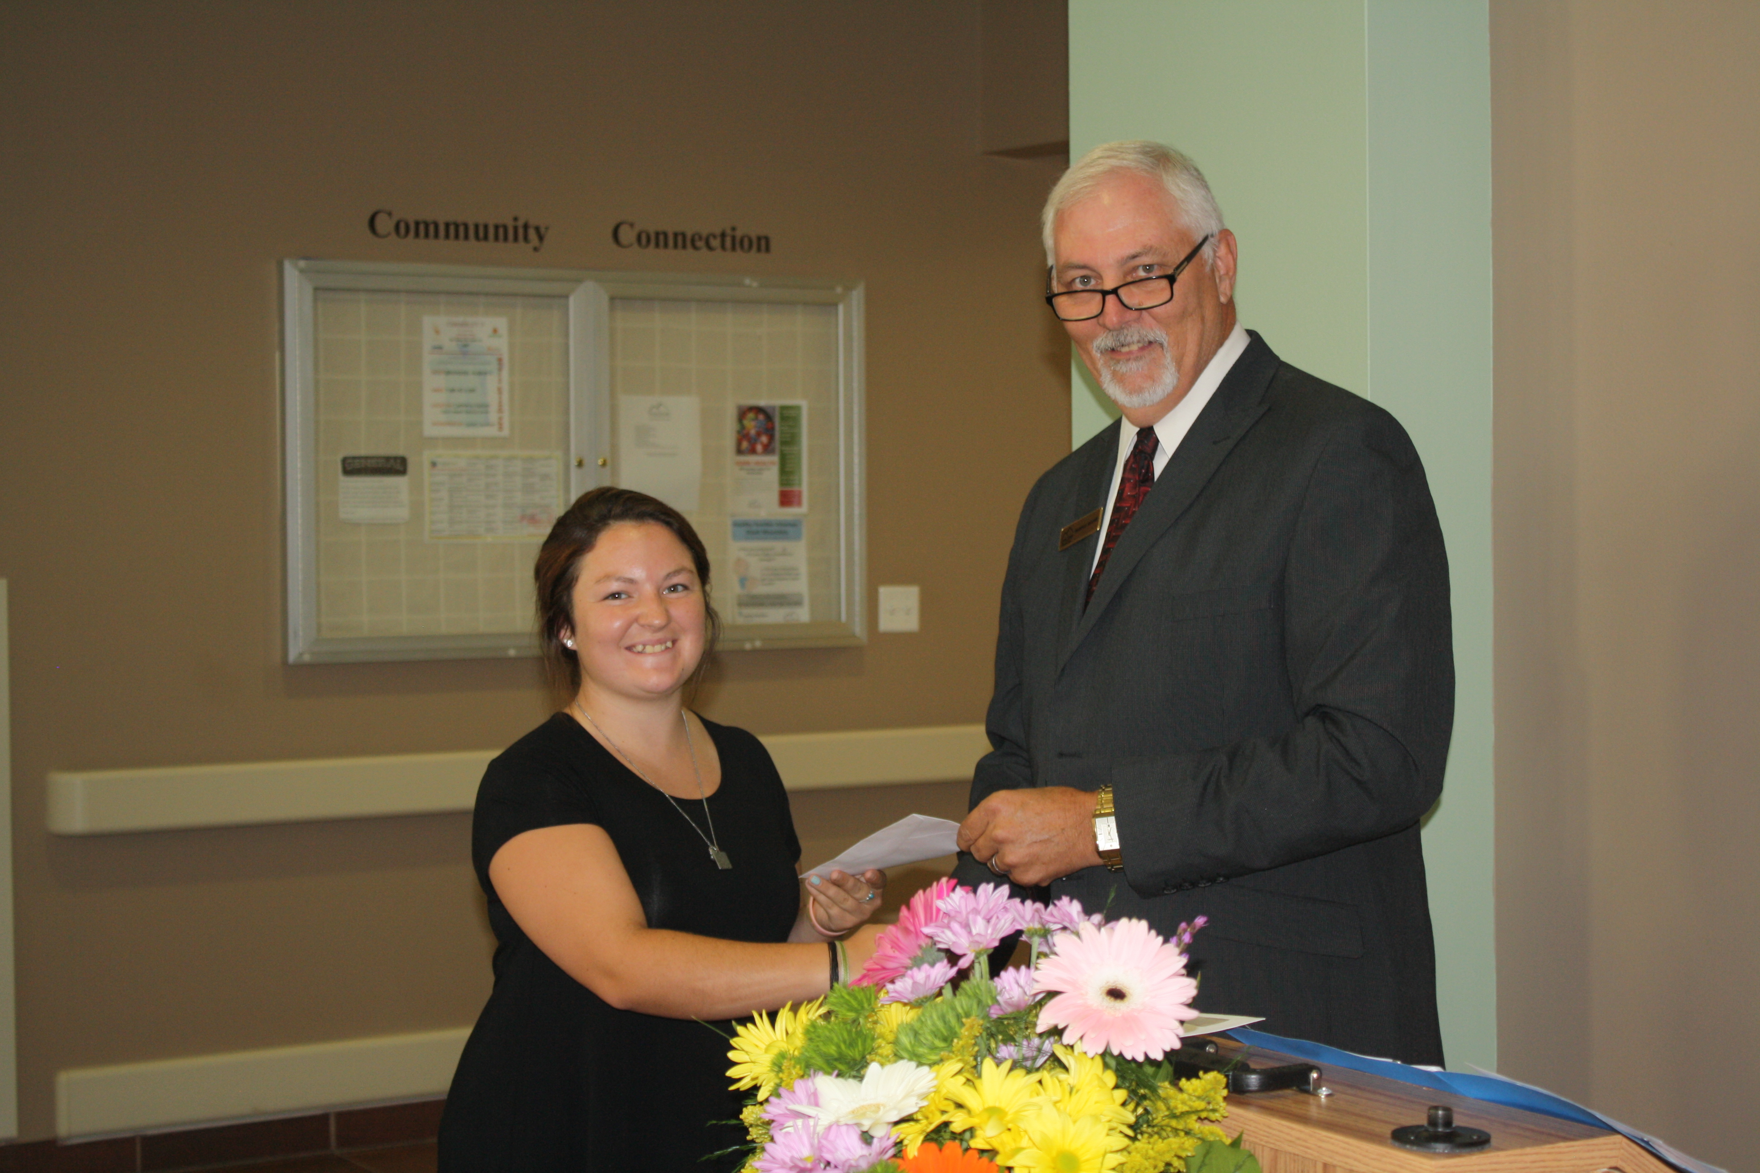

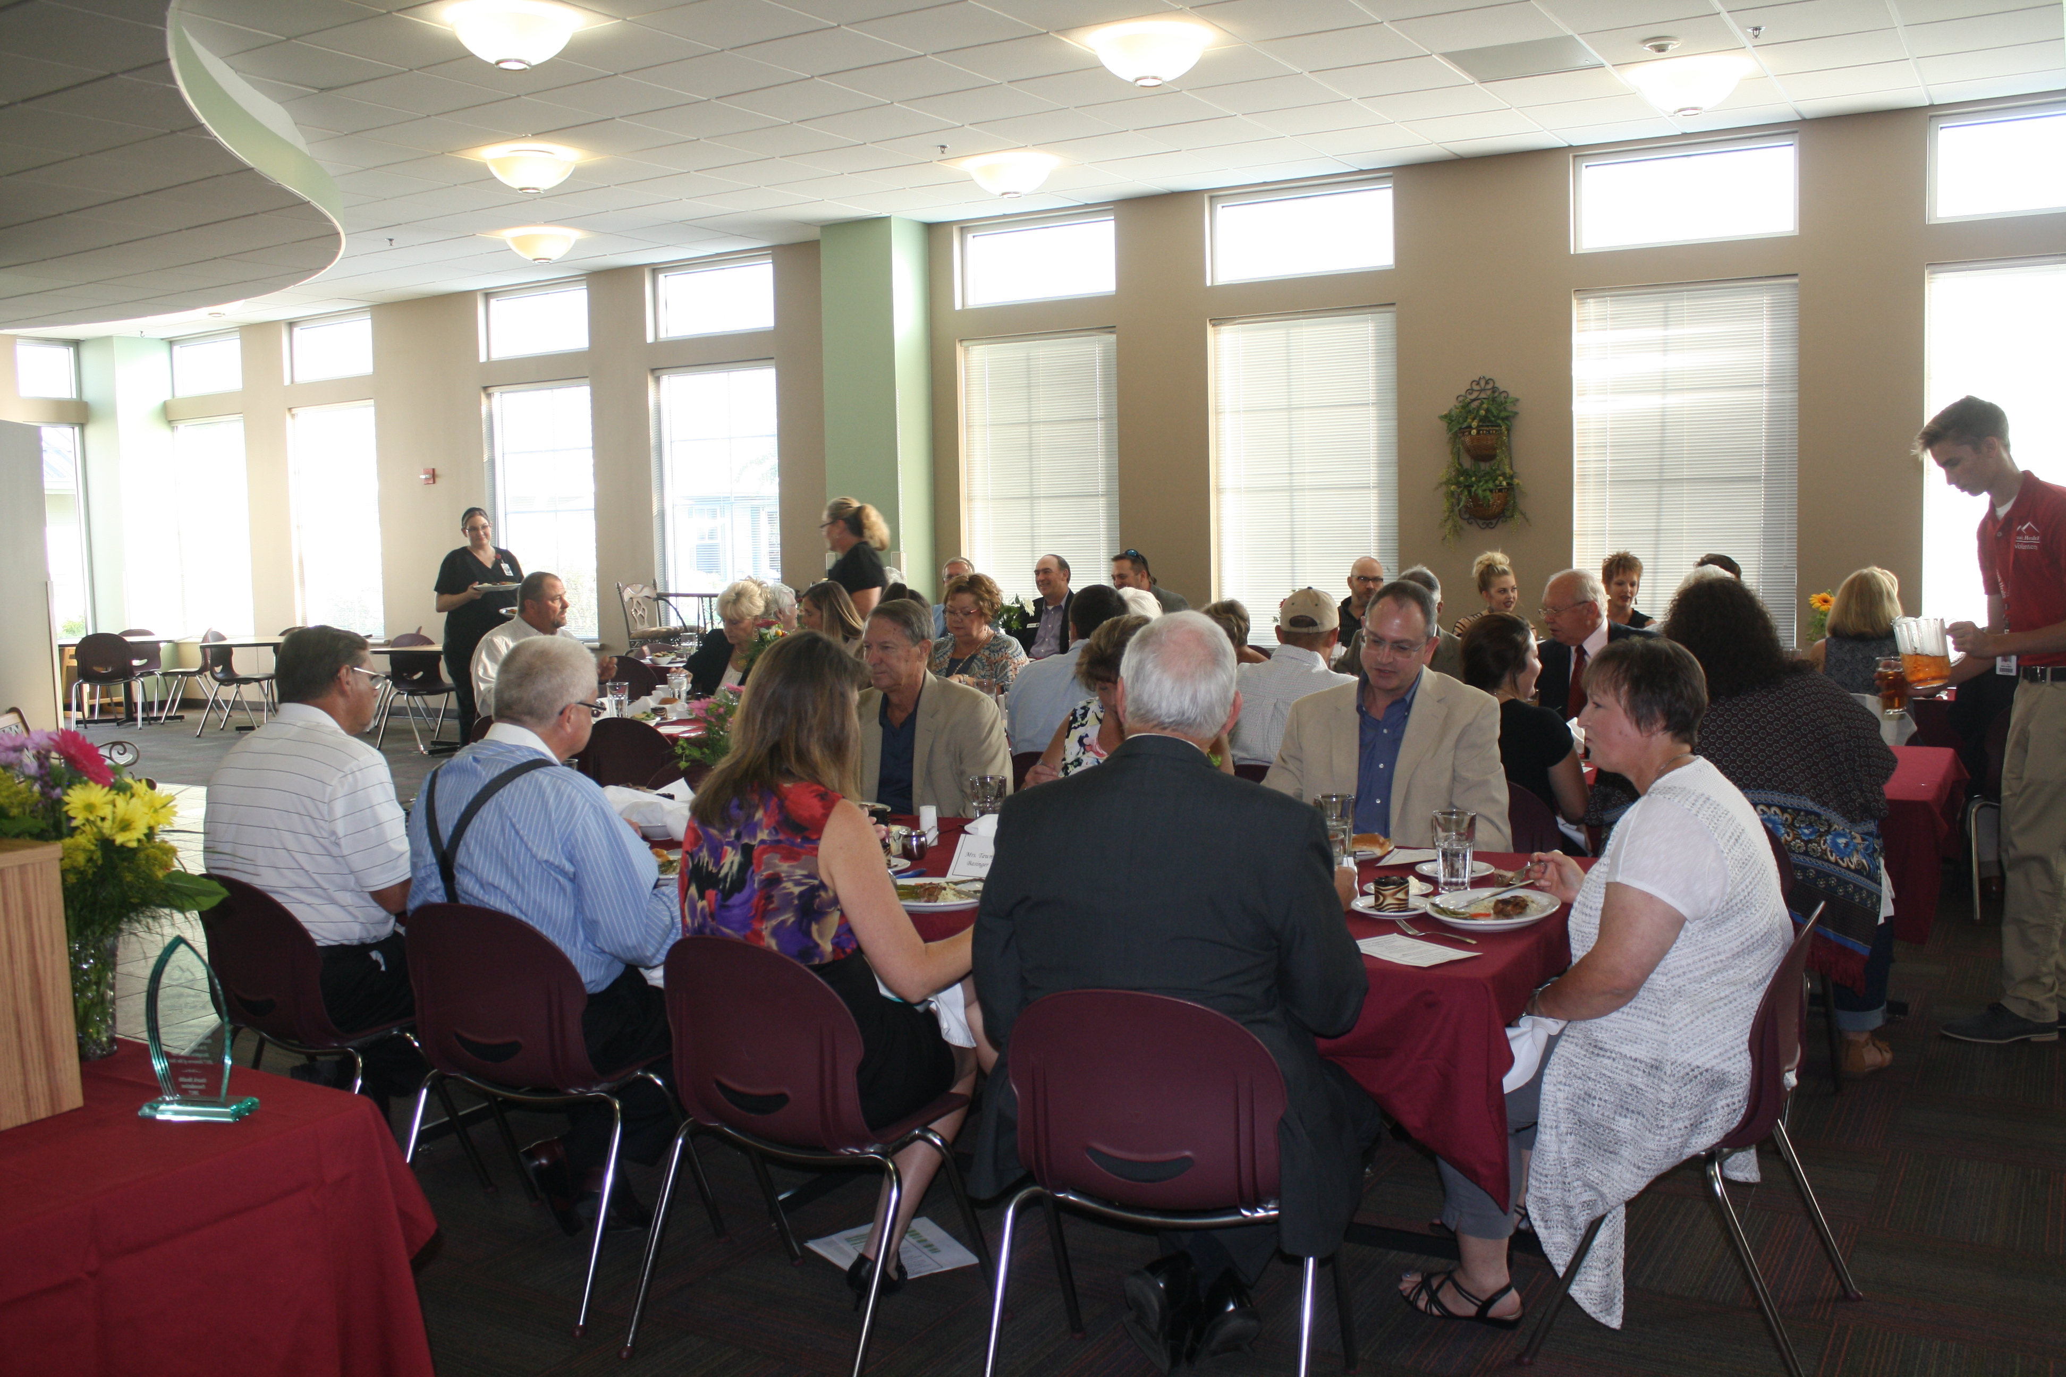

Healthy Families Arkansas™- Ozark Mountains

Healthy Families Arkansas™ – Ozark Mountains (HFA-Ozark Mountains) serves families with young children
in Van Buren and Searcy Counties. Families are enrolled during pregnancy or before the child is 3 months
old, but can remain in the program until the child turns 3 years old. All families served fall below the poverty
level and face at least one other challenge, such as single parenthood, adverse childhood experiences, low education, teen parenting, chronic illness, premature birth, and/or child developmental delay. HFA-Ozark Mountains is voluntary, so all families involved choose to enroll and receive parenting support and education
to increase school readiness, promote child physical health and development, promote family self-sufficiency, increase access to medical and community services, reduce child maltreatment, and promote positive parenting. The program also provides monthly group meetings, connections to local resources, and routine screenings for child development and maternal depression.

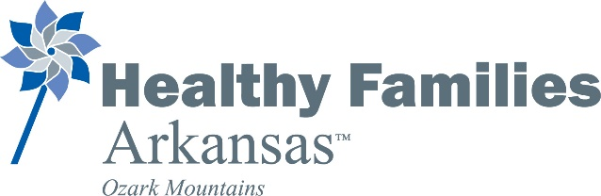

Service Staff
Program Coordinator: Melissa Smyth
Family Support Specialists: Brandi Grillot and Alex Churches

Funding Source
Maternal, Infant, and Early Childhood Home Visiting (MIECHV) grant through Arkansas Children’s Hospital

Community Partnerships
Adult Education Center
Arkansas Children’s Hospital- Injury Prevention Center
Boston Mountain Rural Health Center
Clinton Schools
Cooperative Extension Service
DHS- Division of Children and Family Services
DHS- Division of County Operations
Department of Health
Educational Opportunity Center
First Baptist Church – Marshall
Friendship Community Care
Growing a Healthy Searcy County Committee
HIPPY Home Visiting Program
Juvenile Services
Kirk of the Hills Presbyterian Church- Fairfield Bay
Ozark Health Foundation
Ozark Health Home Care
Ozark Medical Clinic
Ozark Mountain School District- St. Joe
Ozark Opportunities
Searcy County Library
Searcy County School District- Marshall
Southside- Bee Branch Schools
UAMS Child Passenger Safety Education Program
Van Buren County Library
Van Buren County TEA Coalition

Biggest Program Goals:
- Maintain program enrollment of at least 26 families
- Increase number of referrals to local resources for each family
- Connect 100% of families to health care services

Biggest Program Accomplishments:
- Became accredited through Healthy Families America in December 2016
- Became a Satellite Site for Child Passenger Safety and Safe Sleep through University of Arkansas for Medical Sciences’ education program
- Received a “Best in Class Award” for data provided to Healthy Families America, which was featured in their first-ever Home Visiting Yearbook

Plan for Sustainability:
Continue to build and sustain community partnerships with the purpose of continuing these services to Van Buren and Searcy County families. At this time, MIECHV funding is available through 2019.
How does this program make the community better?
Being in such rural areas, families are often isolated, so HFA-Ozark Mountains brings important education and resources to families in their home. This keeps them informed and gives them support so that their babies can have the best start in life and be prepared for success when they begin school.

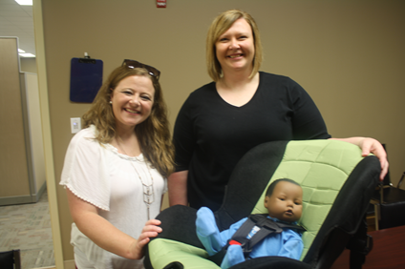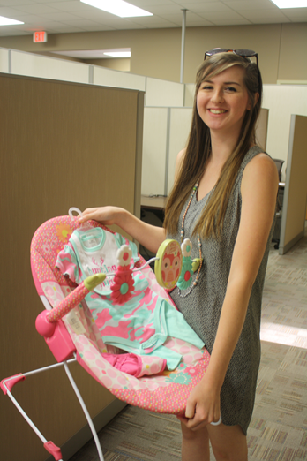
Van Buren County TEA Coalition
The purpose of the Van Buren County TEA Coalition is to prevent prescription drug abuse and underage drinking among youth.
Program Coordinator: Brian Henderson, May 2013 - Present Funding Sources:
  - Drug Free Communities (DFC) Grant (October 2007—September 2018)

Current Partnerships:
  - Arkansas Department of Health
  - Van Buren County—DHS
  - KATV—Channel 7
  - VBC Law Enforcement
  - Clinton Police Dept.
  - Clinton Rotary Club
  - Clinton Chamber of Commerce
- Van Buren County School Districts
- 20th Judicial District Prosecuting Attorney’s Office
- Ministerial Alliance
- 20th Judicial District Drug Crime Task Force
- KHPQ –Radio

Biggest Program Accomplishments (July 2007—June 2017):
- Distributed over 1,500 medication lock boxes to the community through various events and awareness campaigns.
- Added 2 new prescription collection drop boxes that have been donated to the county with a total of 4 locations in Van Buren County.
- Sponsored and hosted a youth summit with Ray Lozano, drug prevention specialist and youth motivational speaker. There were 2,600 2nd-12th grade students that learned about the dangers of drugs and alcohol.
4) Past 30-day use of marijuana decreased 5.7% from 7.8 to 2.1. Prescription drugs decreased 5.2% from 8.2 to 3.
Alcohol decreased 18.4% from 27.2% to 8.8%.

Biggest Program Goals (July 2015—June 2016):
- Continue to hold regular monthly coalition meetings regardless of funding
- Increase community participation with Drug Take Back Events
- Re-structure Coalition Subcommittees

Plan for Sustainability:
We will continue to collaborate with other local organizations to reduce the cost of implementing activities that educate our community about the consequences of underage drinking and the use of other drugs. of funding.

Return on Investment (ROI):
$10.00/dollar spent

Story from Brian:
The TEA Coalition welcomes anyone that wants to get involved in education, encouraging, and inspiring citizens of Van Buren County to practice healthy behaviors and build toward a drug free community.

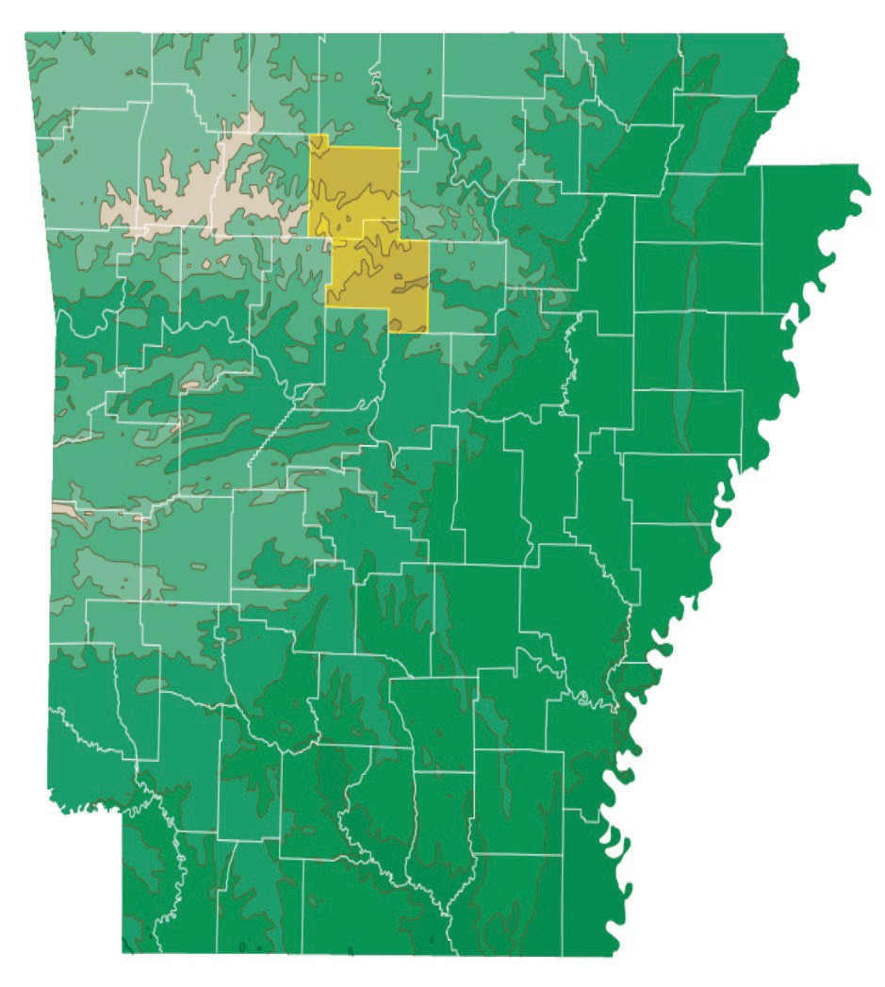
Source: Arkansas Hometown Locator

Community Demographics

Van Buren County Searcy County

Total Population | 17,090 | 7,869
Under 20 years | 23.8% | 20.3%
20 to 59 years | 47.1% | 48.0%
60 years and older | 30.4% | 24.2%
Median Age | 47.0 years | 46.7 years
Males | 49.9% | 49.7%
Females | 50.1% | 54.9%
Disabled | 5.4% | 7.1%
Medicaid Beneficiaries | 25.8% | 33.7%
Medicare Beneficiaries | 20.8% | 19.0%

Source: US Census Bureau, 2006-2010 American Community Survey

Source: US Department of Labor Bureau of Labor Statistics
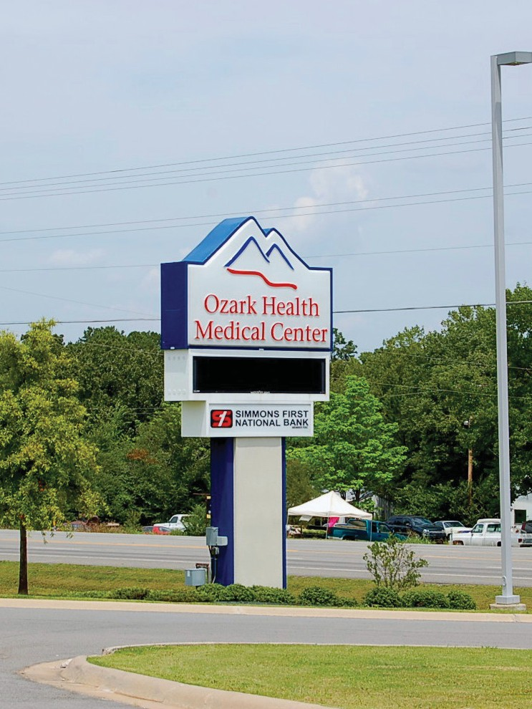
2017 Workforce Data
- Searcy County employed 1513
- Searcy County Unemployment rate was 4.4%
- Searcy County average weekly wage was $530

- Van Buren County employed 3533
- Van Buren County unemployment rate was 7.1%
- Van Buren County average weekly wage was $680

Top Health Issues Identified

Top community problems identified:

- Obesity- Nutrition & Fitness

- Substance Abuse- Tobacco, Alcohol, & Illegal Drugs

Specific Goals & Objectives within Each of the Identified Focus Areas

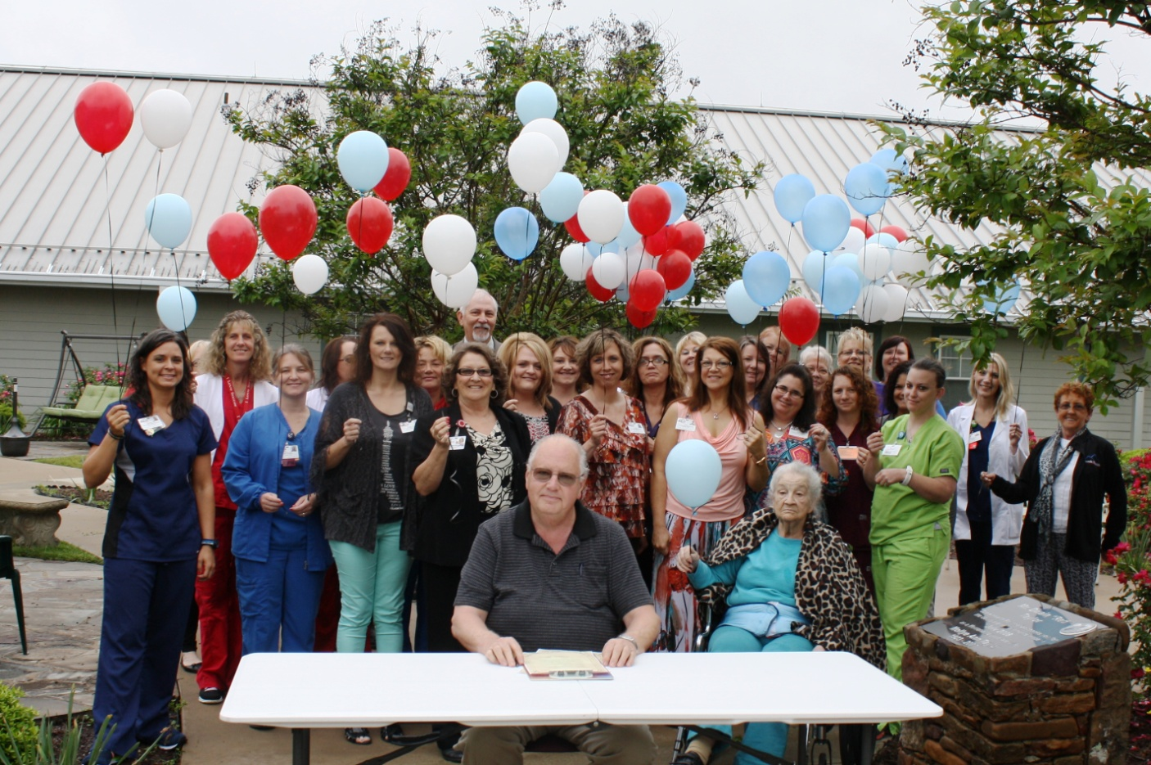

2016-2019
Obesity

Goal 1: Decrease the burden and incidence of obesity-related diseases by implementing community-based approaches to health improvement and weight reduction in Van Buren and Searcy Counties.

Objective 1: Educate the community regarding the importance of health and wellness beginning July 1, 2016 and continuing through June 30, 2019.

Objective 2: Educate the community and local providers of Ozark Health Medical Center nutritional services available between July 1, 2016 and June 30, 2019.

Objective 3: Partner with Ozark Mountain Health Network’s Young Moms Healthy Families Program to support breast feeding in both Van Buren and Searcy Counties, providing education on the importance of breastfeeding for 30 young mothers ages 12 and up between July 1, 2013 and June 30, 2016.

Objective 4: Encourage whole family obesity prevention activities by sponsoring community events with a focus on physical activity, providing financial and/or staff support for a minimum of 6 events between July 1, 2016 and June 30, 2019.

Objective 5: Increase participation in Ozark Health Medical Center’s Cardiac Rehabilitation program to reduce morbidity rates and occurrence of future heart attacks for persons who have already suffered a heart attack from an average of 13 patients annually to 15 patients annually by
June 30, 2019.

Accomplishments

Clinical Dietician Monica Hunt conducted health and wellness classes to the staff of Ozark Health. This was a two-part class. Class one was on goal setting. Class two covered eating healthy. In total, 14 people participated in the classes, 6 completed the class, and 2 chose to follow up and seek more information.

Judge Roger Hooper has implemented an initiative to increase activity in the state of Arkansas, especially Van Buren County. The plan is in place to reduce obesity rates in VBC, reduce drug and tobacco use in VBC, create a community wellness center, health education, mental health resources, disability services, diabetes education, and raise awareness of the benefit of a health life style, Brian Henderson currently serves on the committee, Brian is the TEA Coalition Coordinator for Ozark Health.

Alex Churches, Family Support Worker for Healthy Families Arkansas-Ozark Mountains, has been certified as a breast feeding peer counselor for Ozark Health. She currently serves six families.

Substance Abuse
2016-2019

Goal 2: Decrease the number of Van Buren and Searcy County residents abusing tobacco, alcohol, and illicit and prescription drugs to create a healthier community

Objective 1: Partner with the Van Buren County TEA Coalition to ensure a minimum of 10 meetings each year from July 1, 2016 through June 30, 2019 in each county with the purpose of decreasing substance abuse rates.

Objective 2: Ensure that Van Buren and Searcy County residents are safely disposing of unused prescription medications to keep them out of the hands of youth and other unintended recipients by hosting booths bi-annually at National Drug Take-Back Events across Van Buren and Searcy Counties, holding a total of 12 events between July 1, 2016 and June 30, 2019.

Objective 3: Provide tobacco prevention and cessation information to staff and students at each of the schools within Van Buren and Searcy Counties annually between July 1, 2013 and June 30, 2019.

Objective 4: Implement Brief Tobacco Interventions and cessation efforts for patients at Ozark Health Medical between July 1, 2016 and June 30, 2019.

Objective 5: Educate 500 Van Buren and Searcy County residents annually on Substance Abuse Prevention resources and Ozark Health Medical Center programs available in the 2-county area through local food banks, for a total of 1,500 contacts made between July 1, 2016 and June 30, 2019.

Accomplishments

TEA Coalition Meeting Minutes
January 19, 2017
In attendance: Craig Golden (Pastor-Bee Branch Baptist Church), Michelle Wilson (Southside High School), Alex Churches (Young Moms), Tiffany Drennan (Health Care Professional), Brandi Grilliot (Young Moms), Brian Henderson (Coalition Coordinator)

Meeting Started at 12:00 pm

Minutes
- Motion was made by Randy Churches and seconded by Michelle Wilson to approve November Meeting minutes. All coalition members approved minutes.

Committee Updates:

Young Moms Healthy Families- Brandi Grillot and Alex Churches
- Program is at capacity. Still accepting referrals.
- New referral screening process
- Started a Mom’s Club to offer service without being in Young Moms program
- Working towards a safe sleep program and child safety sear program.

DFC-Brian Henderson
- 1,165 Prescription Medication Lock boxes distributed to date.
- New Project Officer for DFC Ms. Jackie Williams
- Planning for 2017 Youth Summit has begun. First Baptist Church will host us again this year.
- Registered for CADCA’S National Leadership Forum in National Harbor, MD.

Emerging Drug Trend By Teens: Ketamine

- Ketamine is a short-acting dissociative drug, one of two types of hallucinogens. It’s used medically as a tranquilizer or anesthetic.
- Ketamine is manufactured as an injectable liquid although most abusers evaporate it into a powder-often referred to as “ketamine powder”.
- Use, purchase and sale of ketamine at parties, dance clubs and raves have only grown since then, solidifying it as a “club drug.” Ketamine is also known as a “date rape drug” and is often used to facilitate sexual assault because it’s odorless, tasteless and produces an amnesia effect.
- Ketamine dealers are frequently in the news for burglarizing veterinary clinics in search of the controlled substance. Theft is the most frequent way dealers obtain the drug. In some cases, the drug is also smuggled into the US from overseas because in some countries, like England and Mexico, it is legal, making it easier to obtain and cheaper to buy.
- Once evaporated into a powder or compressed into pills, ketamine is often bought and sold at nightclubs, parties, and raves.
- There is several slang terms associated with ketamine, including: K, Special K, Vitamin K, Cat Valium, Green, and Jet.
Other Business
- Budget Carryover Request for $52,127.38 was presented to Coalition. Coalition members present voted in favor of the request unanimously.

No further business was needed and meeting adjourned at 1:00 pm

TEA Coalition Meeting Minutes
February 16, 2017
In attendance: Michelle Wilson (Southside High School), Alex Churches (Young Moms), Dione Henry (Health Care Professional), Brandi Grilliot (Young Moms), Cindy Jones (Ark. Department of Health), Neil Wilkins (VBC Special Schools), Neil Wilkins III (Boston Mtn), Brian Henderson (Coalition Coordinator)

Meeting Started at 12:00 pm

Minutes
- Motion was made by Alex Churches and seconded by Brandi Grillot to approve January Meeting minutes. All coalition members approved minutes.

Committee Updates:

Young Moms Healthy Families- Brandi Grillot and Alex Churches
- Program is at capacity. Still accepting referrals.
- New referral screening process

DFC-Brian Henderson
- 1,172 Prescription Medication Lock boxes distributed to date.
- DFC Reporting completed and finished.
- Attended CADCA’S National Leadership Forum in National Harbor, MD.
- Still in planning stage of Youth Summit to be held at First Baptist Church.
- Save a Life Tour will be coming March 27,28,29.

Poisoning in Arkansas
Presented by Cindy Jones (ADH)
No further business was needed and meeting adjourned at 1:00 pm

TEA Coalition Meeting Minutes
March 16, 2017
In attendance: Michelle Wilson (Southside High School), Kimberly Boren (Arkansas Dept. of Health), Dione Henry (Health Care Professional), Neil Wilkins (VBC Special Schools), Chris Meier (Arkansas Dept. of Health), Marie Slack (Ozark Opportunities), Darrell Moore (Ozark Health), Brian Henderson (Coalition Coordinator)

Meeting Started at 12:00 pm

Minutes
- Motion was made by Michelle Wilson and seconded by Dione Henry to approve February Meeting minutes. All coalition members approved minutes.

Committee Updates:

Young Moms Healthy Families- Brandi Grillot and Alex Churches
- 31-young moms in program.
- Transitioning to Healthy Families Arkansas Ozark Mountains

DFC-Brian Henderson
- 1,190 Prescription Medication Lock boxes distributed to date.
- DFC Reporting completed and approved.
- DFC Continuation Application completed and approved.
- Helping with After Prom Parties for all 3 schools by giving $1,000 to each school to help with t-shirts.
- Youth Summit will be May 2 at First Baptist Church.
- Save a Life Tour will be coming March 27,28,29.

“Dripping” A New Dangerous Trend for Teens who Vape
- 1 in 4 high school teens who have used e-cigarettes have also tried a potentially dangerous new vaping method called “dripping”- dropping e-cigarette liquid directly into the hot coils of the device to produce thicker, more flavorful smoke.
- “Dripping” which differs from normal e-cigarette use that slowly releases the liquid from a wick onto a hot atomizer, may expose users to higher levels of nicotine and to harmful non-nicotine toxins, such as formaldehyde and acetaldehyde- known carcinogens.
- 64% of the surveyed teens said they dripped for the thicker smoke, 39% for the better flavor, and 28% for the stronger throat hit or sensation, according to the study published by the journal Pediatrics.

No further business and meeting was adjourned at 1:00

TEA Coalition Meeting Minutes
April 20, 2017
In attendance: Michelle Wilson (Southside High School), Kimberly Boren (Arkansas Dept. of Health), Dione Henry (Health Care Professional), Alex Churches (Young Moms), Randy Churches (Law Enforcement), Brandi Grillot (Young Moms), Darrell Moore (Ozark Health), Pam Leal (Health Care Professional), Brian Henderson (Coalition Coordinator)

Meeting Started at 12:00 pm

Minutes
- Motion was made by Michelle Wilson and seconded by Pam Leal to approve April Meeting minutes. All coalition members approved minutes.

Committee Updates:

Young Moms Healthy Families- Brandi Grillot and Alex Churches
- 31-young moms in program.
- Transitioning to Healthy Families Arkansas Ozark Mountains

DFC-Brian Henderson
- 1,210 Prescription Medication Lock boxes distributed to date.
- Save A Life Tour was a success.
- Gave Presentation to Marshall Rotary Club about Prescription Drug Abuse.
- National Drug Take Back Day scheduled for April 28 @ Goode’s Cash Saver from 10 - 2.
- Youth Summit will be May 2 at First Baptist Church.
- Ozark Health’s “Big Event” scheduled for May 6 @ Ozark Health from 8 – 1.

Prescription Drug Abuse: A National Epidemic

- Addiction starts with abuse. Abuse of prescription narcotic painkillers sits at the heart of the epidemic. Forty-five people die every day from opioid prescription painkillers – more deaths than heroin and cocaine overdoses combined.
- But it’s not all patient driven: research from 2016 reveals that when U.S. doctors give their patients narcotic painkillers, 99% of them hand out prescriptions that exceed the federally recommended three-day dosage limit.
- Teen Statistics: After marijuana and hash (36%), amphetamines (6.7%) like Ritalin or Adderall account for most of the top drugs abused by 12th graders in the past year
- The top prescription drugs abused by teens included the stimulants like Adderall (amphetamine mixed salts), tranquilizers, opioids like Vicodin (acetaminophen/hydrocodone), sedatives and cough medicines.

No further business and meeting was adjourned at 1:00

TEA Coalition Meeting Minutes
May 18, 2017
In attendance: Pam Leal (Health Care Professional), Mary Eakin (Ark. Dept. of Health), Kortney Fowler (Ozark Health-Media), Cara Holland (Ozark Health-Media), Marie Slack (Ozark Opportunities Inc), Brian Henderson (Coalition Coordinator)

Meeting Started at 12:00 pm

Minutes
- Motion was made by Pam Leal and seconded by Cara Holland to approve April Meeting minutes. All coalition members approved minutes.

Committee Updates:

YDFC-Brian Henderson
- 1,250 Prescription Medication Lock boxes distributed to date.
- National Drug Take Back Day was a success. Passed out 15 prescription lock boxes and collected over 40 pounds of prescription drugs.
- THUGS Scholarships Awarded to Jadon Price (Southside), Mackenzie Mosley (Southside), and Libby Walsh (Clinton)
- Youth Summit was a success. 30 Thugs from Southside and Clinton were in attendance
- Ozark Health’s “Big Event” passed out drug abuse information and talked to over 80 people about the importance of talking to their kids about the dangers of alcohol and drugs.

“Gray Death” The New Powerful Street Drug

- It’s the latest killer drug cocktail making headlines in the South.
- What is Gray Death? Start with Heroin mix in the powerful painkiller fentanyl, add a dash of carfentanil, and top it off with a synthetic opioid called U-47700, better known on the streets as “Pink”
- The drug gets its name from how it looks. Gray Death looks like concrete mix and varies in consistency from a hard, chunky material to a fine powder.

No further business and meeting was adjourned at 1:00

TEA Coalition Meeting Minutes
July 20, 2017
In attendance: Pam Leal (Health Care Professional), Mary Eakin (Ark. Dept. of Health), Kortney Fowler (Ozark Health-Media), Cara Holland (Ozark Health-Media), Michelle Wilson (Southside Schools), Donna Branscum (Ark. Dept of Health), Leeanna Brown (Juvenile Court), Brian Henderson (Coalition Coordinator)

Meeting Started at 12:00 pm

Minutes
- Motion was made by Pam Leal and seconded by Cara Holland to approve July Meeting minutes. All coalition members approved minutes.

Committee Updates:

YDFC-Brian Henderson
- 1,265 Prescription Medication Lock boxes distributed to date.
- Registered for CADCA’S Mid-Year Training Conference in Atlanta, GA.
- Named to committee for Van Buren County Health Improvement by Judge Roger Hooper. Purpose is discussing ideas on how to improve the health and well-being of Van Buren county residents.
- Working on new THUG T-shirts designed by THUGS
- Working on new billboard aimed at the dangers of “Texting and Driving” designed by THUGS.

Coalition discussed end of year budget money to be spent.
$10,000.00 – Clinton EAST Lab
$10,000.00- Southside EAST Lab
$1,500.00- THUG T-Shirts
$1,500.00- TEA Coalition T-Shirts
$2,000.00- Texting and Driving billboard
$5,000.00- MVCI Conference for Drug Task Force
$5,000.00- Prescription Drug Lock Boxes
Discussed the possibility of providing Narcan for Sherriff’s Department and Clinton Police.

No further business and meeting was adjourned at 1:00

TEA Coalition Meeting Minutes
September 15, 2016
In attendance: Renee Kyle (Other ATOD Org.), Donna Branscum (VBC Health Dept.), Sayde Horton (Boston Mountain), Pam Leal (Health Care Professional), Randy Churches (Law Enforcement), Darrell Moore (Business-Ozark Health), Roger Hooper (VBC County Judge), Neil Wilkins (VBC Special Schools), Mary Eakin (Ark. Dept. of Health), Neil Wilkins III (Boston Mountain), Amy Wilson (Southside High School Counselor), Brian Henderson (Coalition Coordinator)

Meeting Started at 12:00 pm

Minutes
- Motion was made by Randy Churches and seconded by Donna Branscum to approve Meeting minutes. All coalition members approved minutes.

Committee Updates:

Young Moms Healthy Families- Melissa Smyth
- Enrolled 28th family this week. Capacity is 30 so almost there.
- Accreditation has been submitted and set to go in front of board September 27 for program accreditation
- Set up booth at VBC Fair and passed out educational materials

DFC-Brian Henderson
- 1,146 Prescription Medication Lock boxes distributed to date.
- DFC Reporting completed and submitted.
- Met with all 3 county schools and passed out THUG applications. All 3 schools are participating in THUGS this year.
- Met with Amanda Powell with KATV Channel 7 about THUG productions for the year.
- Met with Tim Smith principal at Southside Schools about Red Ribbon Week kickoff. Speaker will be Chris Sandy
Using Morning Glory Seeds to get High
- Ingesting morning glory seeds can cause hallucinations common knowledge in the 1960’s that apparently is being relearned by a new generation of youth
- Teens are eating or brewing morning glory seeds for an LSD-like high
- Morning glory seeds contain lysergic acid amide, similar to the active ingredient in LSD; they can be chewed or brewed into a tea to release the substance
- The threshold amount for morning glory is about 50 seeds
- The common dosage is between 100 – 250 seeds, while anything over 400 seeds is considered heavy
- The most common side effect of morning glory are nausea and vomiting. Other negative effects may include anxiety, paranoia and a general sense of unease. These pass with they primary effects.

TEA Coalition Meeting Minutes
October 20, 2016
In attendance: Donna Branscum (VBC Health Dept.), Michelle Wilson (Southside High School), Alex Churches (Young Moms), Dione Henry (Health Care Professional), Brian Henderson (Coalition Coordinator)

Meeting Started at 12:00 pm

Minutes
- Motion was made by Donna Branscum and seconded by Dione Henry to approve September Meeting minutes. All coalition members approved minutes.

Committee Updates:

Young Moms Healthy Families- Alex Churches
- Currently trying for new money for the program.
- Brandi and Melissa attended training for Child Car Seat Safety Education.

DFC-Brian Henderson
- 1,150 Prescription Medication Lock boxes distributed to date.
- DFC Reporting approved by Project Officer.
- All 3 schools are participating in THUGS this year. 31-Southside, 30-Clinton, and 9-Shirley.
- Red Ribbon Week kickoff @ Southside School. Speaker will be Chris Sandy
Carfentanil: A Dangerous New Factor in the U.S. Opioid Crisis
- Carfentanil is a synthetic opioid approximately 10,000 times more potent than morphine and 100 times more potent than fentanyl.
- The presence of carfentanil in illicit U.S. drug markets is cause for concern, as the relative strength of this drug could lead to an increase in overdoses and overdose-related deaths, even among opioid-tolerant users.
- The presence of carfentanil poses a significant threat to first responders and law enforcement personnel who may come in contact with this substance.
- Carfentanil and other fentanyl analogues present a serious risk to public safety, first responder, medical, treatment, and laboratory personnel.
- These substances can come in several forms, including powder, blotter paper, tablets, patch, and spray.
- Some forms can be absorbed through the skin or accidentally inhaled.
- If encountered, responding personnel should do the following based on the specific situation: Exercise extreme caution, Be Aware of any sign of exposure, Seek IMMEDIATE medical attention. Be ready to administer naloxone in the event of exposure and remember that carfentanil can resemble powdered cocaine or heroin.
- Carfentanil is used as a tranquilizing agent for elephants and other large mammals. The lethal dose range for carfentanil in humans is unknown; however, carfentanil is approximately 100 times more potent than fentanyl, which can be lethal at the 2-milligram range, depending on route of administration and other factors.
- SA causes vasoconstriction, the narrowing of blood vessels which increase blood pressure. Painful or uncomfortable legs are a sign of lowered blood flow to the muscles and indicate that a break from morning glory seeds is necessary.

No further business was needed and meeting adjourned at 1:00 pm

TEA Coalition Meeting Minutes
November 17, 2016
In attendance: Donna Branscum (VBC Health Dept.), Michelle Wilson (Southside High School), Alex Churches (Young Moms), Dione Henry (Health Care Professional), Brandi Grilliot (Young Moms), Brian Henderson (Coalition Coordinator)

Meeting Started at 12:00 pm

Minutes
- Motion was made by Donna Branscum and seconded by Michelle Wilson to approve October Meeting minutes. All coalition members approved minutes.

Committee Updates:

Young Moms Healthy Families- Brandi Grillot and Alex Churches
- Program is at capacity. Still accepting referrals.
- New referral screening process
- Started a Mom’s Club to offer service without being in Young Moms program
- Working towards a safe sleep program and child safety seat program.

DFC-Brian Henderson
- 1,159 Prescription Medication Lock boxes distributed to date.
- Red Ribbon Week kickoff @ Southside School. Had over 1,000 9th-12th-grade students in attendance from Clinton and Southside.
- Red Ribbon Week door decorating contest. Judged each school Red Ribbon Week door decorations.
- Gave presentation at Clinton Jr. High School. Encouraged students to make “Right” choices in their life. Spoke to over 400 students.
- Attended 2016 Prescription Drug Abuse Summit in Little Rock.

Emerging Drug Trend by Teens: Ketamine

- Ketamine is a short-acting dissociative drug, one of two types of hallucinogens. It’s used medically as a tranquilizer or anesthetic.
- Ketamine is manufactured as an injectable liquid although most abusers evaporate it into a powder-often referred to as “ketamine powder”.
- Use, purchase and sale of ketamine at parties, dance clubs and raves have only grown since then, solidifying it as a “club drug.” Ketamine is also known as a “date rape drug” and is often used to facilitate sexual assault because it’s odorless, tasteless and produces an amnesia effect.
- Ketamine dealers are frequently in the news for burglarizing veterinary clinics in search of the controlled substance. Theft is the most frequent way dealers obtain the drug. In some cases, the drug is also smuggled into the US from overseas because in some countries, like England and Mexico, it is legal, making it easier to obtain and cheaper to buy.
- Once evaporated into a powder or compressed into pills, ketamine is often bought and sold at nightclubs, parties, and raves.
- There is several slang terms associated with ketamine, including: K, Special K, Vitamin K, Cat Valium, Green, and Jet.

Drug Take Backs
1. Drug take back was held at Clinton Arkansas Cash Saver. A pickup truck of prescription drugs was taken out of the hands of community members. The local pharmacy also contributed their take back drugs to the efforts.

2. Drug take back was held at Terry Gage Chevrolet in Marshall, Arkansas. Approximately 7 Walmart bags of prescription drugs were brought in from the community.

How to Make the Most of our Efforts
2016-2019

Goal 3: Increase community awareness of available health related resources and programs in the Van Buren and Searcy County area.

Objective 1: Present to local community, civic, and volunteer groups quarterly to inform them about the obesity treatment and prevention related programs that are available in Van Buren and Searcy Counties, providing a minimum of 4 presentations each year beginning July 1, 2016 and ending June 30, 2019. (Potential groups to present to: Senior centers, Rotary, Chambers of Commerce, The CALL, DHS, Ministerial Alliance)

Objective 2: Review and update the booklet containing all available health and substance abuse prevention related programs and resources in Van Buren and Searcy Counties by December 1, 2017.

Objective 3: Utilize a variety of outlets to distribute 2,000 resource directories annually listing all available health and substance abuse prevention related programs and resources in Van Buren and Searcy Counties between July 1, 2016 and June 30, 2019. (Publication sources/ avenues: Water bills, Newspapers, Daycares, Churches, Chamber of Commerce, Free booths at community events, Booth at County Fair, Health Fairs, Food 4 life, Food bank, Social media, WIC clients)

Objective 4: Utilize social media, such as Facebook, Twitter, and web pages, to educate youth and adults on the dangers of substance abuse and making unhealthy choices between July 1, 2016 and June 30, 2019.

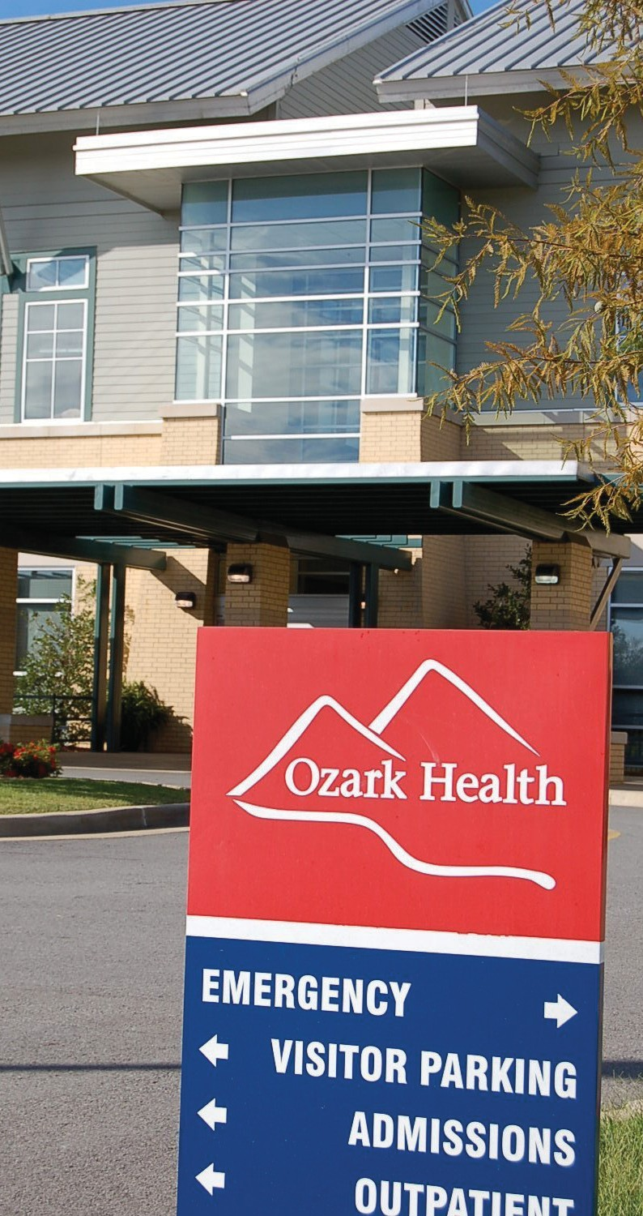

Looking to the Future…
Over the next three years we will implement the programs that were identified as avenues to address the needs that were identified through our Community Health Needs Assessment. As the three-year period draws to an end, we will begin the process over of addressing current needs and gaps in services and compare
the most recent Behavior Risk Factor Surveillance Survey data and our county rankings to the data that was used in this year’s Community Health Needs Assessment. We will evaluate program specific data and the goals and objectives listed in this report. Then we will create a new updated Needs Assessment to identify what problems we
are facing at that time and create solutions to address those
problems within our community.

Ozark Health Services

The following pages contain a list of the hospital departments offering services to the community along with the services they provide and contact information. There are too many services to list in this report, however, if you ever have any questions about other services available, feel free to call the hospital’s front desk staff at 501-745-7000 anytime.

Cardiac Rehabilitation

Services and other information: The Cardiac Rehabilitation Program can be utilized with orders from a prescribing physician. The program is aimed at rehabilitating individuals who have recently had one of the diagnoses below:

- Myocardial Infarction
- Angina Pectoris (stable for at least 2 months)
- Coronary Artery Bypass Surgery,
- Heart Valve Repair/Replacement
- PTCA or Coronary Stinting
- Heart/Heart Lung Transplant

Hours/ Days of Operation: Mondays, Wednesdays, and Fridays 1:30 – 2:30 PM (By appoint- ment only)

Contact Person: Tona Alford, RN

Direct Telephone Number(s): 501-745-9594

Dietary

Services and other information: A full cafeteria for the public and catering services is available through Ozark Health’s Dietary Department.

Hours/ Days of Operation: The kitchen operates 7 days a week from 6:30 AM-6:30 PM for both cafeteria and catering services.

Ozark Health Services

Dietary (continued)
Contact Person: Peggy Zoch,

Direct Telephone Number(s): 501-745-9567

Emergency Department

Services and other information: The Emergency Department provides around-the-clock emergency medical care, with a Physician on the premises at all times. Laboratory, Radiology, and Pharmacy services are available at the discretion of the attending Physician, as well as, a variety of Therapy services. In addition, we participate in the ARSaves Telemedicine Program, which provides immediate Stroke Treatment using state-of-the-art computerized connection with Physicians at UAMS. Also, all trauma information and images are sent through an online repository to insure faster image and data transfers. Emergency Department staff also has consultation services with Arkansas Children’s Hospital for both Pediatric and Burn patients.

Hours/Days of Operation: The Emergency Department is open 7 days a week, 24 hours a day, 365 days a year.

Contact Person: Randi Jeffries

Direct Telephone Number(s): 501-745-9442

Home Health Care

Services and other information: Ozark Health Home Care provides skilled nursing visits in the home including: home IV infusion, wound care (including wound vacs), nursing assessments and health education, Pediatric and Mental Health Nursing. In addition, in home therapy is available in the forms of: Physical Therapy, Speech Therapy, and Occupational Therapy.

Ozark Health Services

Home Health Care (continued)

Home Health Aides area also available for personal care and bathing. We have on staff a Certified Pediatric Nurse Specialist and Certified Psychiatric Nurse Specialist and all of our Nursing Staff are trained as Chronic Care Specialists. We have almost 300 years combined nursing experience to meet your “at home” needs.

Hours/Days of Operation: Office hours are 8:00 AM – 4:30 PM Monday – Friday with RN’s and LPN’s on call 24 hours a day, 7 days a week.

Contact Person: Pam Leal

Direct Telephone Number(s): 501-745-7004 option 2

Laboratory

Services and other information: All general clinical laboratory services are available. Appointments are required for the following tests: Therapeutic Phlebotomies; Oral Glucose Tolerance Tests; Drug Screen Collections that require Chain-of-Custody Protocol (NOTE: We do NOT provide DOT drug screen collections); And any test that may require special supplies (i.e. Paternity Collection Kits)

Hours/ Days of Operation: The laboratory is staffed 7 days a week, 24 hours a day. However, normal outpatient hours are from 8 AM until 5 PM weekdays (except holidays). Patient s can be seen outside of these hours, but we ask that prior arrangements be made.

Contact Person: Jack Riddle, Lab Manager

Direct Telephone Number(s): 501-745-9450 (Lab Front Office) 501-745-9461 & 501-745- 9456 (Main Lab) 501-745-9469 (Manager’s Office)

Ozark Health Services

Med/Surg

Services and other information: The Med/Surg department specializes in quality care for patients who are staying at the facility for any length of time for observation or swingbed services.

Hours/ Days of Operation: Med/Surg staff work 7 days a week, 24 hours a day, 365 days a year.

Contact Person: Angie Roberts, RN

Direct Telephone Number(s): 501-745-9414

Nursing Center

Services and other information: Our wide array of services enables our patients and residents to receive the medical care they need, the skilled therapy and nursing services they require, and the support they and their families deserve. The uniqueness of our facility being joined with Ozark Health Medical Center allows for an extension of those specialized services not normally found in a long term care setting. We serve many types of patient and resident needs, from short-term rehabilitation to traditional long-term care.

Working with your physician, our staff nurses, therapists, dietitian and social worker establishes a comprehensive treatment plan intended to restore you or your loved one to the fullest practicable potential.

Hours/Days of Operation: 24 hours a day, 7 days a week, 365 days a year

Contact Person: Carla Roberts, RN, Administrator

Direct Telephone Number(s): 501-745-9517

Ozark Health Services

Outpatient Services

Services and other information: Outpatient Services are any services provided to patients that are not patients staying in the Hospital or Nursing Home at the time.
The Outpatient Services provided at our facility include:
- Intramuscular (IM) & subcutaneous (SQ) Injection Administration
- Intravenous (IV) Fluid Hydration / Infusion Administration
- Intravenous (IV) Push Medication Administration
- By Mouth (PO) Medication Administration
- Post Chemotherapy Medications
- i.e. Neulasta, Neupogen, Procrit & Aranesp
- Joint Disease Medications
- i.e. Orencia, Boniva, Prolia & Reclast
- Iron Deficiency Medications
- i.e. Feraheme and Ferrlicit
- Blood Thinning Medications
- i.e. Arixtra and Lovenox
- Power Port/Infusa Port/Pediatric Port/Peripherally Inserted Central Catheter (PICC Line)/or other Central Venous Catheter
- Lab Draw
- Irrigation
- Medication Administration
- Dressing Change
- Blood/Blood Components Transfusion and Administration
- In and Out Catheterization
- Foley Catheter Placement and/or Foley Bag Replacement
- Enema
- Dressing changes
- Tuberculin Skin Testing
Hours/Days of Operation: Monday–Friday, 8:00 AM–5:00 PM Contact Person: Tona Alford, RN
Direct Telephone Number(s): 501-745-9594

Ozark Health Services

Patient Financial Counselor

Services and other information: This department assists patients with questions regarding account balances and the financial assistance application process.

Hours/Days of Operation: Staffed Monday – Friday from 10:30 AM- 6:00 PM, the Financial Counselor will be happy to help answer any questions you may have

Contact Person: Kathy Potts

Direct Telephone Number(s): 501-745-9521

Quality

Services and other information: The Quality Department offers the following services: Community and Individual Education

Community Chronic and Acute Disease Management and Treatment Community and Hospital Infection Control
Emergency Preparedness- both Hospital and State-Wide

Hours/ Days of Operation: Quality services are available Monday-Friday from 6:30 AM- 5:00 PM

Contact Person: Lisa Stephenson, BSN, RN

Direct Telephone Number(s): 501-745-9418

Ozark Health Services

Radiology

Services and other information: Ozark Health offers a professional, highly qualified Radiology staff. Radiology exams performed at Ozark Health are read by Radiology Associates, PA. And Echocardiograms are interpreted by cardiologists.

Services Provided Include: X-Ray and Fluoroscopy exams, CT exams including CT angiography, MR exams including MR angiography, Digital Mammography with Computer-Aided Detection, Ultrasound including echocardiograms and stress echocardiograms.

Hours/Days of Operation: Radiology services are available 24 hours a day. Outpatient exams are available Monday through Friday.

Contact Person: Jamie Cates MS, BSRT, (R) (M)

Direct Telephone Number(s): 501-745-9542

Rehabilitation Services

Services and other information: The Rehab Department specializes in Physical Therapy, Occupational Therapy, and Speech/ Swallowing Therapy. All therapy services are available through: In-patient, Out-patient, Nursing Home, and Home Health settings.

Hours/Days of Operation: Monday – Friday 7:30 AM – 5:30 PM

Contact Person: Larry Green, PT

Direct Telephone Number(s): 501-745-9486

Ozark Health Services

Respiratory Care

Services and other information: All employees of the department are Cardiopulmonary Resuscitation (CPR), Advanced Cardiac Life Support (ACLS), and Pediatric Advanced Life Support (PALS) Certified. We have the entire spectrum of experience from Neonates to Geriatrics and are working towards starting a Pulmonary Rehabilitation Program, as well.

Services offered by the Respiratory Therapy Staff include:
Complete Pulmonary Function Testing, Treadmill Stress Tests, Stress Echo, Non-Invasive Ventilation, Ventilator Management, Holter Heart Monitors, Cardiac Event Monitors, All forms of Bronchodilator Administration, Education about Respiratory Medications and proper use, Tobacco Prevention Education.

Hours/ Days of Operation: Respiratory Therapy staff is available 7 days a week, 24 hours a day.

Contact Person: Jay Whitmire

Direct Telephone Number(s): 501-745-9471 or 501-745-9448

Scheduling/ Pre-Registration

Services and other information: The Scheduling and Pre-Registration Department works to ensure that your visit to the hospital is as quick and simple as possible by scheduling
appointments referred by Physician’s Offices, as well as assisting patients with pre-registering for future services.

Hours/ Days of Operation: Scheduling and Pre-Registration services are available Monday- Thursday from 8 AM – 4 PM.

Contact Person: Vicky Watkins

Direct Telephone Number(s): 501-745-9506

Ozark Health Services

Specialty Clinic

Services and other information: The Specialty Clinic Physicians listed below are some of the best physicians in the state. Your doctor or primary care physician may refer you to any of our many specialists to target certain conditions. You may also refer yourself to one of our doctors, as many insurance plans do not require physician-to-physician referral. It is recommended
that you call your insurance company to confirm that you are able to do this before making an appointment.

Specialists currently available at the Specialty Clinic are:
Cardiology- Douglas Borg, M.D. Cardiology- Donald Meacham, M.D. Cardiology- Ben Starnes, M.D. Dermatology- Francine Bruyneel, M.D.
General Surgery- Steve Schoettle, M.D. , FACS Gynecology- Josh Ward, M.D. and Heather White, A.P.N Nephrology- Mary Jo Shaver, M.D.
Orthopedic- Hank Wallace, M.D. Otolaryngology- Jeffery Barber, M.D. Podiatry- Glenn McClendon, D.P.M Rheumatology- Ronald Rubio, M.D., F.A.C.R. Urology- Caleb Bozeman, M.D.

Hours/ Days of Operation: The Specialty Clinic is staffed Monday – Friday from 8:00 AM – 4:30 PM for scheduling and questions, however Physician Hours and Clinic Times vary based on their individual clinic days.

Contact Person: Janet Hall

Direct Telephone Number(s): 510-745-9439

Ozark Health Services

Surgery

Services and other information: We provide a variety of surgical services. Some of the most common procedures that we do are:

General Surgery- Gallbladder removal, Hernia repair, Hysterectomy, and Skin Lesion, Cyst, and Skin Cancer Removal
Orthopedic Surgery- Total Joint Replacement, Carpal Tunnel Release, Rotator Cuff Repairs, Arthroscopy Surgeries
Ear, Nose, and Throat Surgery- Tonsil and Adenoid Removal, PE Tube Placement Urology Surgery- Prostate Biopsy, Bladder Surgery
GI Procedures- Colonoscopy, EGD, and Peg Tube Placement Hours/ Days of Operation: 6:30 AM – 4:00 PM Monday - Friday Contact Person: Michelle Reeves, Surgery Manager
Direct Telephone Number(s): 501-745-9555 or 501-745-9556

